Welcome!
Date
Name
Spouse
Address
City
State Zip _________
Email

Please Contact By
❑ Card  Phone  Visit

Telephone Best Time to Call
Home ______________
Work ______________

Guest: First Time Second Time
Are you a church member: yes no
Church
City, State

Circle Appropriate Age/Grade Group(s)
Preschool: Ages: B-1 2-3 4-5
Children: Grades: K 1 2 3 4 5 6
Youth: Grades: 7 8 9 10 11 12
Adults: Ages:18-29 30s 40s 50s 60s+

How did you learn about our church?
Newspaper Friend Yellow Pages Mail
Other

I am a guest of:

New in the Community? Yes No
Names & ages of children at home

Weekly Service & Activity Schedule

November 15, 2015

9:45 a.m. Sunday School
11:00 a.m. Worship Service
6:00 p.m. Evening Worship/Business Meeting

Week of November 15, 2015
Wednesday 6:30 pm Meal/ Adult Bible Study

Upcoming Events

November
21………………………………….Merrell/Edwards Wedding
26………………………………………..………..Thanksgiving
December
Nov 29 – Dec 5…..Week of Prayer – Lottie Moon Missions
13……………..……………..Children’s Christmas Program
20…………………………………………….Business Meeting



Kenny & Rachel
are
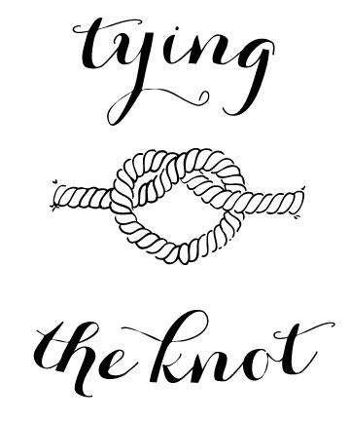
Saturday, Nov 21, 2015

It’s time to start packing Thanksgiving boxes for those in the community in need. If you would like to help in this wonderful mission, contact Evelyn Robinson.





Knobbs Springs Baptist Church

November 15, 2015

Church Information:

KnobbsSpringsBC.com KnobbsSpringsBaptist@gmail.com

1662 CR 305, McDade, Texas 78650 512-273-2743

David Atwood, Pastor Cell 512-470-5098
Home 512-856-2819
Patti Radford, Office Manager Cell 512-968-7821

